**EXPERIMENT – 4 AND 5:**

Practicing DDL Commands(Data Defination Language)

* CREATE TABLE Command
* ALTER TABLE Command
* TRUNCATE TABLE Command
* DROP TABLE Command

**CREATE TABLE Command**:

CREATE TABLE Persons (PersonID numeric(20 key) primary , Last_Name varchar(20),

FirstName varchar(20),City varchar(55));

Desc Persons;

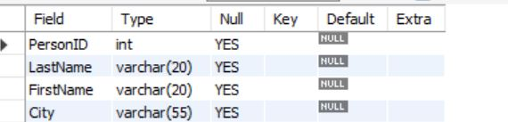

**ALTER TABLE Command: -**

ALTER TABLE Persons add Adrress varchar(100);



**DROP TABLE Command:-**

DROP TABLE Persons; 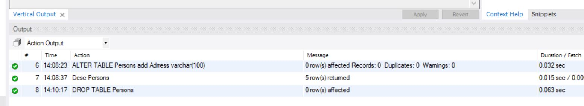

**TRUNCATE TABLE Command:-**

CREATE TABLE Students( First_Name varchar(20), Last_Name varchar(20) , Pin_No varchar(20) primary key ,Dept varchar(30));

TRUNCATE TABLE Students;

